EUROPEAN COMMISSION
DIRECTORATE-GENERAL
ENVIRONMENT



GRANT
APPLICATION FORMS

2009 CALL FOR PROPOSALS

CIVIL PROTECTION FINANCIAL INSTRUMENT

FOR COOPERATION PROJECTS ON:

PREVENTION

AND

PREPAREDNESS

FORMS A and T

NOTE:

Note that the Financial Forms are in a separate file.

FORMS A:

Summary and Administrative Information

Form A1

EUROPEAN COMMISSION
ENVIRONMENT DG

 |  | EUROPEAN COMMISSION  ENVIRONMENT DG |  | for commission use only
 |  |  |  | Proposal n°

PROJECT

Project title (max. 60 characters):……………………………………………………………………………………….
..........................................................................................................................................................

Project acronym (max. 25 characters): ………………………………………………………………………………..

The project will be implemented in the following country(ies): ………………………………………………………………………………………………….………………………………………………………………………………………………………………………………….

………………………………………………………………………………………………………………………………

………………………………………………………………………………………………………………………………

Starting date: ...................... Ending date: .......................... Duration in months (max 24): ……………

COORDINATING beneficiary and ASSOCIATED BENEFICIARIES

Name of coordinating beneficiary (CO): ...............................................................................................................
Name of associated beneficiary (AB1) …………………………………………………………………………………
Name of associated beneficiary (AB2): …………………………………………………………………………………
Name of associated beneficiary (AB3): …………………………………………………………………………………
(Continue as necessary)

Project Budget and REQuested EC funding
Total project eligible cost: ……………. €
EC financial contribution requested: ……………. € ( = …….. % of total eligible costs)

PROJECT POLICY AREA / THEME

PREPAREDNESS (please choose only one category):
Exchange of information, experience, good practices and knowledge aiming at increasing the performance of civil protection actors (professional and volunteers) operating in the Member States as well as increasing public awareness.
Cross border civil protection cooperation regarding the direct response to natural and man-made disasters
Enhancement of the availability of Civil Protection modules and other resources
PREVENTION

Form A2

COORDINATING BENEFICIARY DECLARATION

The undersigned hereby certifies that:

- The specific actions listed in this proposal do not and will not receive aid from the Structural Funds or other Community financial instruments. In the event that any such funding will be made available after the submission of the proposal or during the implementation of the project, my organisation will immediately inform the European Commission.

- My organisation has not been served with bankruptcy orders, nor has it received a formal summons from creditors. My organisation is not in any of the situations listed in Articles 93.1 and 94 of Council Regulation 1605/2002 of 25/06/2002 (OJ L248 of 16/09/2002).

- My organisation will contribute …………€ to the project. My organisation will implement the following actions ... … … … … … , with an estimated total cost of ... … … … €.

- Should one or more associated beneficiary or co-financier reduce or withdraw its financial contribution, my organisation will ensure that a corresponding additional contribution is made available.

- My organisation will conclude with the associated beneficiaries and co-financiers any agreements necessary for the completion of the work, provided these do not infringe on their obligations, as stated in the grant agreement with the European Commission. Such agreements will be based on the model proposed by the European Commission. They will describe clearly the tasks to be performed by each associated beneficiary and define the financial arrangements.

- I am aware that my organisation is solely legally and financially responsible to the Commission for the implementation of the project (Article 4 of the Common Provisions).

I am legally authorised to sign this statement on behalf of my organisation.

I have read in full the Common Provisions (attached to the Model Grant Agreement provided with the application files).

I certify to the best of my knowledge that the statements made in this proposal are true and the information provided is correct.

At ................................................. on (date).......................................................
Signature of the Coordinating Beneficiary:
Name of Coordinating Beneficiary: ...........................................................................................
Name(s) and status of signatory: .........................................................................................
Form A3
ASSOCIATED BENEFICIARY DECLARATION AND MANDATE

The undersigned hereby certifies that:
- My organisation has not been served with bankruptcy orders, nor has it received a formal summons from creditors. My organisation is not in any of the situations listed in Articles 93.1 and 94 of Council Regulation 1605/2002 of 25/06/2002 (OJ L248 of 16/09/2002).
- My organisation will contribute …………€ to the project. My organisation will implement the following actions ... … … … … … , with an estimated total cost of ... … … … €.
- My organisation will conclude with the coordinating beneficiary an agreement necessary for the completion of the work, provided this does not infringe on our obligations, as stated in the grant agreement with the European Commission. This agreement will be based on the model proposed by the European Commission. It will describe clearly the tasks to be performed by my organisation and define the financial arrangements.
- For the purposes of the implementation of the agreement regarding this project between the European Commission and the coordinating beneficiary:
a) My organisation grants power of attorney to the coordinating beneficiary, to act in our name and for our account in signing the above-mentioned agreement and its possible subsequent riders with the European Commission. Accordingly, my organisation hereby mandates the coordinating beneficiary to take full legal responsibility for the implementation of such an agreement.
b) My organisation hereby confirms that we have taken careful note of and accept all the provisions of the above agreement with the European Commission, in particular all provisions affecting my organisation and the coordinating beneficiary. In particular, my organisation acknowledges that, by virtue of this mandate, the co-ordinator alone is entitled to receive funds from the Commission and distribute to my organisation the amount corresponding to our participation in the action.
c) My organisation hereby agrees to do everything in our power to help the coordinating beneficiary fulfil his obligations under the above agreement. In particular, my organisation hereby agrees to provide him whatever documents or information may be required, as soon as possible after receiving his request.
d) The provisions of the above agreement, including this mandate, shall take precedence over any other agreement between my organisation and the coordinating beneficiary which may have an effect on the implementation of the above agreement between the coordinating beneficiary and the Commission.

I am legally authorised to sign this statement on behalf of my organisation.

I have read in full the Common Provisions (attached to the Model Grant Agreement provided with the application files).

I certify to the best of my knowledge that the statements made in this proposal are true and the information provided is correct.

At ................................................. on (date).......................................................
Signature of the Associated Beneficiary:
Name of Associated Beneficiary: ...........................................................................................
Name(s) and status of signatory: .........................................................................................
Form A4
COORDINATING BENEFICIARY PROFILE
 | Coordinating Beneficiary Profile Information
Short Name |  |  |  |  |  | Participant ref. |  |  |  | CO
Legal information on the Coordinating Beneficiary
Legal Name |  |  |  |  |  | Legal Status
VAT No |  |  |  |  |  | Public  Private  Natural person
Legal Registration No
Registration Date
 |  |  |  |  |  | International organisation
Legal address of the Coordinating Beneficiary
Street Name and No |  |  |  |  |  |  |  | PO Box
Post Code |  |  | Town/City
Country Code |  |  | Country Name
Coordinating Beneficiary contact person information (only if different to above)
Title |  |  | Function
Surname |  |  |  |  | First Name
Department / Service Name
Street Name and No |  |  |  |  |  |  |  | PO Box
Post Code |  |  | Town/City
Country
Telephone No |  |  |  |  | Fax No
E-mail |  |  |  |  | Website
Coordinating Beneficiary details
Number of employees
Number of employees in department conducting project
Is Your Organisation independent (Yes or No)
If No, please indicate legal name(s) of owner(s) who own 25 % or more
Is Your Organisation affiliated to any other participant(s) in the project? (Yes or No)
If Yes, please indicate Participant Short Name(s) and character of affiliations(s)
Brief description of the structure and the activities of the Coordinating Beneficiary

Form A5
ASSOCIATED BENEFICIARY PROFILE (Complete for each Associated Beneficiary)
 | Associated Beneficiary Profile Information
Short Name |  |  |  |  | Participant ref. |  |  | AB…
Legal information on the Associated Beneficiary
Legal Name |  |  |  |  | Legal Status
VAT No |  |  |  |  | Public  Private  Natural person
Legal Registration No
Registration Date
 |  |  |  |  | International organisation
Legal address of the Associated Beneficiary
Street Name and No |  |  |  |  |  | PO Box
Post Code |  |  | Town/City
Country Code |  |  | Country Name
Associated Beneficiary contact person information (only if different to above)
Title |  |  | Function
Surname |  |  |  | First Name
Department / Service Name
Street Name and No |  |  |  |  |  | PO Box
Post Code |  |  | Town/City
Country
Telephone No |  |  |  | Fax No
E-mail |  |  |  | Website
Associated Beneficiary details
Annual turnover |  | Last Financial Year
Number of employees
Number of employees in department conducting project
Is Your Organisation independent (Yes or No)
If No, please indicate legal name(s) of owner(s) who own 25 % or more
Is Your Organisation affiliated to any other participant(s) in the project? (Yes or No)
If Yes, please indicate Participant Short Name(s) and character of affiliations(s)
Brief description of the structure and the activities of the Associated Beneficiary

Form A6

CO-FINANCIER PROFILE AND COMMITMENT (Complete for each co-financier)

Legal Name and full address on the co-financier
Financial commitment
We will contribute the following amount to the project: | ….. €
Status of the financial commitment
Stamp and signature of the authorised person
Name and status of the authorised person (obligatory):
Date of the signature
(obligatory):
Signature (obligatory):

Form A7

OTHER PROPOSALS SUBMITTED FOR COMMUNITY FUNDING

Please answer each of the following questions:

Have you or any of the associated beneficiaries already benefited from previous co-financing under any EU civil protection financial instruments or programmes? (title, year, amount of the co-financing and duration)

Have you or any of the associated beneficiaries already benefited from previous EC financing (grants, procurements or loans) for activities that may relate to the present proposal (e.g. an RTD project preceding the present proposal)? (title, year, amount of financing and duration)

Have you or any of the associated beneficiaries applied for Community funding under any other financial instruments for actions which form part of or are directly related to this proposal? With what results? Please give full details!

Form A8

ENDORSEMENT FROM THE COMPETENT NATIONAL CIVIL PROTECTION AUTHORITY
(for Coordinating Beneficiary)

Name: [name of the national central civil protection authority]

[name of the department in national central civil protection authority]

Contact person: [name of the contact person in the national central civil protection authority]

[position/rank in the national central civil protection authority]

Full address: [street/P.O. Box]
[town]
[country]
[phone]
[Fax]
[E-mail]

Undertakes to support the following project: [project title]
Lead by: …………………………………………… [name of coordinating beneficiary organisation]

The National Central Civil Protection Authority [please tick appropriate box]:

Declares that the project is consistent with the national civil protection plans

Will participate in the steering group / core group of the project

Will attend the major events of the project

Will endorse the outcomes of the project and support their implementation within its Member State

Will financially support the project (see form A6)

Person entitled to enter into commitments on behalf of the national central competent authority | Name:  Status/title:
Signature
Date

Place

Form A9

Example for Legal Entities Form

The Legal Entity form specifically adapted to the legal status of the Coordinating Beneficiary (public entity or private company) as well as to the country/ language is available on
http://ec.europa.eu/budget/execution/legal_entities_en.htm

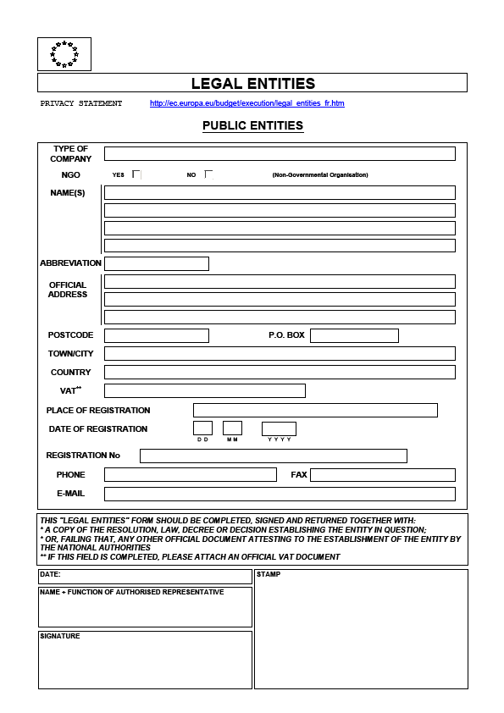
Form A10

Example for Financial Identification Form

The financial identification form specifically adapted to the country/ language of the bank account is available on
http://ec.europa.eu/budget/execution/ftiers_en.htm

Form A11
EUROPEAN COMMISSION
DIRECTORATE-GENERAL
ENVIRONMENT
Directorate A – Communication, Legal Affairs and Civil Protection
ENV.A.3 – Civil Protection

Brussels,
DG ENV.A.3 / D

Name of Coordinating Beneficiary1:

Contact person1:

E-mail or Fax1:

ACKNOWLEDGEMENT OF RECEIPT

Title of the project1: ........

Sir, Madam

I acknowledge receipt of your proposal for which I thank you.

Your proposal will be examined by our services, with respect to its eligibility. Those projects declared eligible will then undergo an evaluation procedure by the Commission.

I will let you know the final decision, as soon as it has been taken.

Yours faithfully,

Signature DG ENV: .......................................................

SECTION T:

Objective, actions and expected results

Project planning and structure

Form T1

SUMMARY OF THE PROJECT (Maximum 1 page)

Objectives

Actions and means involved

Expected results

Form T2

Project Acronym
Task ID | Task Title |  | Start Date |  | End Date | Actions | Deliverables
(Maximum number of tasks – 10)

Form T3a

Project Acronym |  |  |  | T3a - Task Form
Task ID |  | Task Title
Objectives
DESCRIPTION

Action A.1
Name of the action:
Description (what, how and where):
Expected results:
Constraints and assumptions:
Responsible for implementing it:
Action will be subcontracted: Yes/No/Partially

Action A.2
Name of the action:
Description (what, how and where):
Expected results:
Constraints and assumptions:
Responsible for implementing it:
Action will be subcontracted: Yes/No/Partially

Etc.

Form T3b

Project Acronym |  |  |  |  |  | T3b- Task Form |  |  | Page 1 of maximum 10 (1 task per page)
Task ID |  |  | Task Title
Start Date |  |  |  | End Date |  |  |  | Duration
Deliverable Date |  | Deliverable Description

Form T4

CONTINUATION

Continuation after the project ends:

- What still needs to be done (which actions will have to be continued or maintained)

- How will this be achieved, which resources will be necessary to continue the actions?

- How will the equipment acquired be used?

- Which personnel will continue to work on the project?

1
1
1 To be completed by the Coordinating Beneficiary
1

